Programming in Alice
Alice Workshop: Sequential, Parallel and Simple Loop constructs

Learning Objectives
The learning objectives of this workshop are:
- Students can design a simple scenario using a combination of sequential and parallel actions, as well as simple loops
- Students can implement their design using an appropriate combination of constructs.

Exercise 1
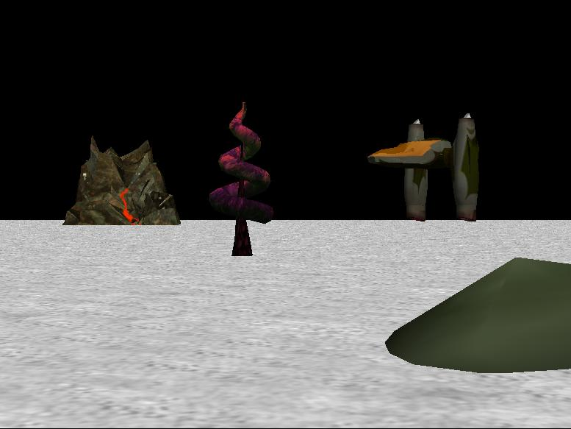
Create a new world using the space theme with a jump jet. In this exercise you will use “do in order” (sequential) and “do together” (parallel) constructs to move the jump jet.
- In my first method, use the move method from the JumpJet object to move the jump jet up 5 metres, then forward 40 metres.
- Modify your code so that the left and right jet engines are turned backwards ¼ of a revolution before the jet moves upwards. You should use a “do together” block to ensure that the two engines are turned at the same time.
- Modify your code so that the jet engines are turned to their starting positions before the jet moves forwards.

Exercise 2
Create a new world with a dinosaur (or other large animal that has a moveable jaw) and a second animal, such as a chicken. In this exercise you will get the dinosaur to turn to face the chicken, then say “Hello” to the chicken while moving its mouth at the same time.
- Write down a pseudo code design for the above scenario.
- Use the “Do together” and “Do in order” constructs to implement the above scenario.
Now modify your code, using a simple loop, so that the dinosaur opens and closes its mouth 2 times each time the dinosaur says something. You will need to change the duration for the jaw movement commands.

Extension Exercise
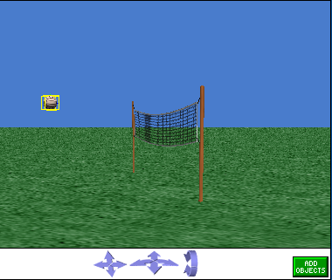
Create a world with a volleyball (Sport) and a volleyball net (Sport) as shown below. Write a program to make volleyball move back and forth from one side of the net to the other. The ball should move upwards as it approaches the net and then back down to its original height as it moves to the other side of the net. The ball should then reverse direction and move back the other way. This should be repeated five times.

