Programming in Alice
Workshop: Creating methods

Learning Objectives
The learning objectives for this workshop are:
- Students can define new methods for existing classes
- Students can define methods with parameters
- Students can use these methods in their programs

Exercise 1
Create a new world that includes the Zeus character (from the People gallery). In this exercise you will create a new method in which Zeus will tell us his name and age.
- Create a new object level method called talk for the Zeus class. To do this click on the Zeus object, then click on the methods tab and finally click on the create new method button.
- In the talk method program Zeus to say “Hello my name is Zeus”, followed by “I am 99 years old”.
- Call the talk method in my first method and run the program.

You will now use parameters to vary the name and age of the character.
- Create a new parameter for the talk method called name. This parameter should have type String.
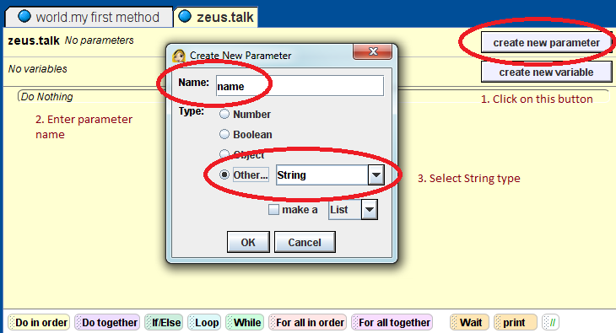
- Change the code inside of the talk method so that the Zeus object say “Hello my name is _name_” (where _name_ will be the value of the name parameter).
- Update the call to the talk method in my first method by passing a value to the name parameter (you can pass it any string – perhaps try your own name).
- Repeat the above steps, but this time adding a second parameter called age, representing the age of the character. You will need to use the string utility functions to combine the age with the other text. The Zeus object should say “I am _age_ years old”.

exercise 2
Create a new world that includes a Humvee object (from Vehicles gallery) and a building or other large object. Your objective is to move the Humvee around the building. To do this you will create methods to drivethe Humvee forward, turn left and turn right.
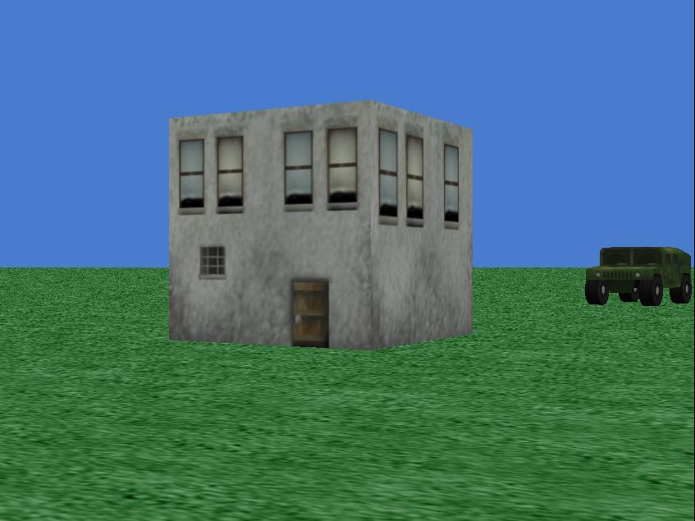
- Create a new method called drive. This method should include a parameter called distance, with type Number. The method should move the Humvee forward by an amount given by the value of distance.
- Call the drive method within my first method to ensure that it works correctly.
- Create a new method called turn_leftthat includes a parameter called revolutionsspecifies the number of revolutions to turn, e.g. a value of 0.25 should turn the Humvee 90 degrees. The method should turn the Humvee left by the amount given by the revolutions variable.
- Repeat the previous step to create a method called turn_right. It should the same as the previous method, except it will turn to the right.
- Call turn_left and turn_right within my first method to ensure the work correctly.
- Using a combination of calls to drive, turn_left and turn_right, get the Humvee to move around the building.

