Programming in Alice
Workshop: indefinite loops

Learning Objectives
The learning objectives for this workshop are:
- Students can design and implement programs using indefinite loops
- Students can use the random number function in their programs
- Students can design and use class level methods

Exercise 1
In this activity you will design and develop a cat and mouse game. The cat chases the mouse at the same time the mouse moves in a random direction trying to evade the cat. When the cat finally catches the mouse it will enjoy a tasty meal. To assist in the development of the program we provide a number of suggested development steps.

Step 1: creating the world
Create a new world that includes a Cat object (Animals) and a Mouse object (Animals). Ensure that the mouse is initially a reasonable distance away from the cat and that it is facing away from the cat. You may wish to add some additional scenery to make the chase a little more interesting.
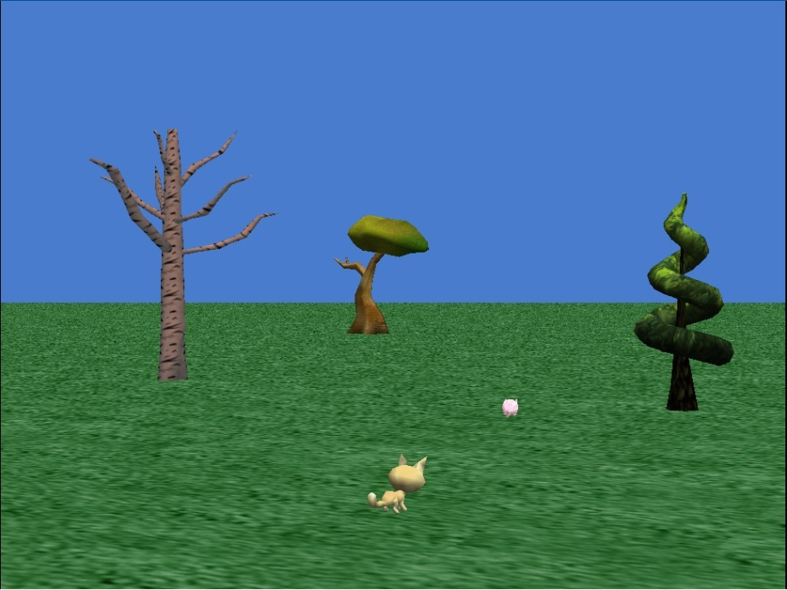

Step 2: creating Chase method
Create a new class method for the Cat class called chase. In this method the cat should turn to face the mouse, then move forward 1 metre. You may wish to add some animation to the cat’s movement, but you should do this after you have completed the other steps.

Step 3: creating run away method
Create a new class method for the Cat class called runAway. In this method the mouse should turn left or right a random amount (up to a maximum of ¼ of a revolution in either direction). You will need to use the random number function to determine the amount to turn. The mouse should then move forward 1 metre.

Step 4: Introducing a loop
In my first methodcreate a while loop. In the body of the while loop you must call the methods chase and runAway. You will need to design a test for the while loop, such that the loop continues until the cat is within a certain distance of the mouse (use an appropriate function to determine the distance between the cat and mouse).

STEP 5: catching the mouse
Create a new class method for the Cat class called eatMouse. The method should perform an appropriate action once the cat catches the mouse. Call the eatMouse method in my first method after the while loop.

Extension: an Alternative ending
Create a new class method for the Mouse class called eatCat. In this method the mouse gets revenge and eats the cat instead. In my first method use the choose true probabilityOfTrue of time(from World object) to call eatMouse 60% of the time and call eatCat the remaining 40% of the time. HINT: you will need to use an if statement.

