Programming in Alice
Alice Workshop: variables and functions

Learning Objectives
The learning objectives of this workshop are:
- Students can design and implement programs that use local variables to store data
- Students can use input functions to get information from the user
- Students can use string utility and random number functions
- Students can use variables in function calls

Exercise 1
Create a new world that includes a person from Person objects. In this exercise you will prompt the user to enter two numbers. These numbers will be stored in variables and sum of the two numbers will be calculated and displayed.
- Create two local variables call in1,in2 and sum, which all have type Number.
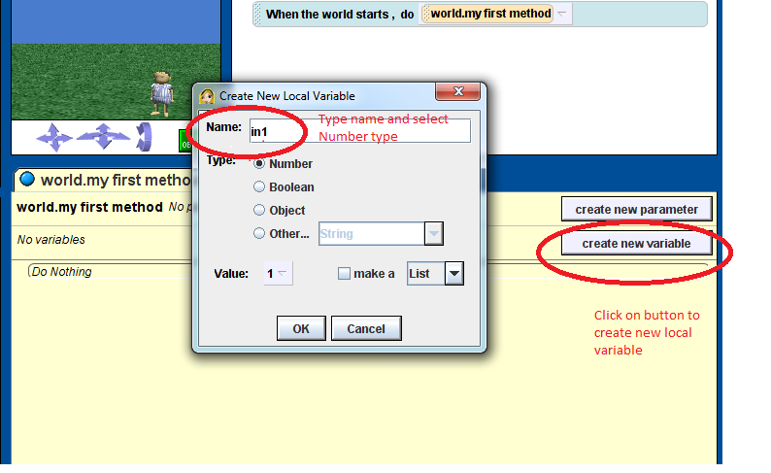
- Use the ask user for a number function to prompt the user to enter two numbers. Assign these two values to the two local variables, in1 and in2.
- Calculate the sum of the two numbers in1 and in2. Assign this value to the local variable sum.
- Program the person object to say “The sum of in1 and in2 is sum”. (Your program should display the values of in1, in2 and sum, e.g. the person would say something like “The sum of 12 and 11 is 23”). You will need to use the string utility functions to create the string output.

Exercise 2
Create a new world and include the Plato person (from the People catalogue). In this exercise you will program Plato to simulate a series of dice rolls and display the results.
- Program Plato to say “I will roll a dice”.
- Create a local variable called diceroll. Assign a random number between 1 and 6 to the diceroll variable using the random number function. Make sure you set the integerOnly option. Note also that when the integerOnly option is used the random number is rounded down to the nearest integer. So you will need to set the minimum to 1 and maximum to 7.
- Program Plato to say “I rolled a ...” (you will need to insert the value of the diceroll variable). You will need to use the string utility functions (string join and what as a string). You will also need to use the int as a String function to ensure that a whole number is displayed.
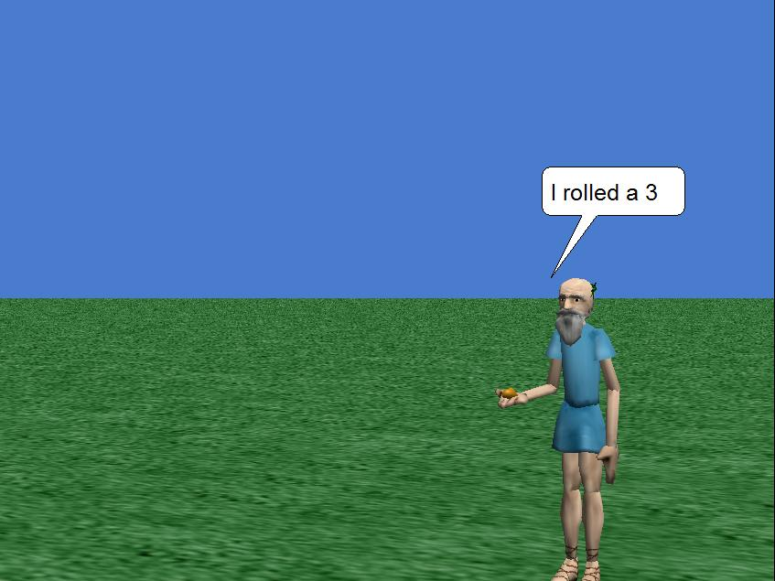
- Add a simple loop so that Plato rolls the dice 5 times.
- Add a new local variable called total; initially total should be set to 0. Each time Plato rolls the dice, add the result of the dice roll to the total.
- Program Plato to say “The total so far is …” (where you will need to insert the value of the total variable).

Extension Exercise
Create a new world and include the pj character (from People). Use the string utility functions, together with the hour of day,minute of hour andsecond of minutefunctions to program pj to tell the time (as shown below). You should firstly create a local variable called time, with String type, to store the current time. Then use the string join function to combine the time with the rest of the output.
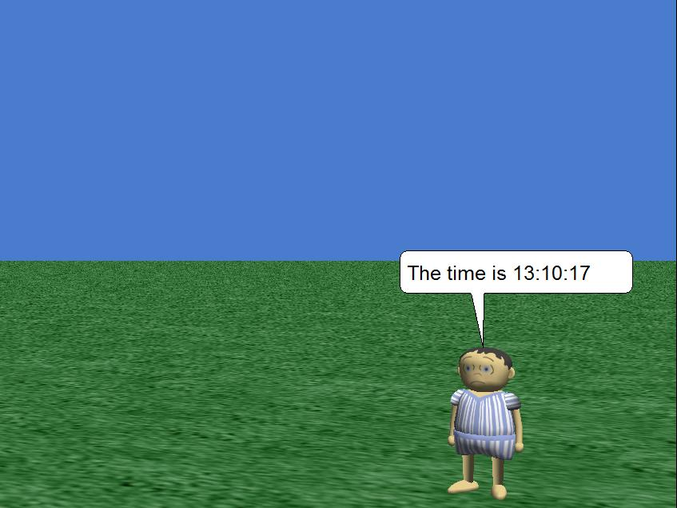
Once you have this working, use an infinite loop to update the time every one second.

