Programming in Alice
practical test 1

Overview
In this practical test you will use the programming constructs that you have learnt to date to complete a number of questions. The practical test should be completed using the PracticalTest1.a2w file. The world for the practice test is very simple; it consists of a kangaroo and two crates. You will be using a variety of constructs to move the kangaroo in different ways. In this practical test you will:
- Use Do in order blocks
- Use Do together blocks
- Use Simple loops
- Use Functions
- Define a new class method
- Use the new class method
For each question you will be required to create a new method for the World object.
To call the new method when you run the program, change the events in the top right hand corner screen. In the image below, the program will call the question1 method from the World object.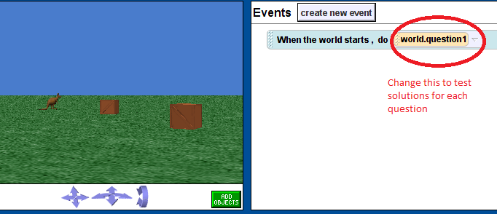

Question 1
Create a new World method called question1. In this method you will
- Move the Kangaroo up 3 metres and then down 3metres. [1 mark]
- Use a simple loop to repeat this process 5 times. [1 mark]
Test the method by calling the question1 method when the world starts (as explained above).

Question 2
Create a new World method called question 2. In this method you will make the Kangaroo hop
- Move the Kangaroo up 1.5metres then down 1.5metres. At the same time the Kangaroo must move forward 2 metres. The Kangaroo must move in a curve. [3 marks]
- Use a simple loop to make the Kangaroo hop 5 times. [1 mark]

Question 3
Create a new World method called question 3.In this method you will make the Kangaroo hop in a square.
- Create a new class method for the Kangaroo object call hop. The hop method must take three parameters, dist_forw, dist_up and dist_down, representing the distance the Kangaroo travels forward, up and down. The method should complete a single hop, as in the first part of question 2, except the distance that the Kangaroo moves forward, up and down is determined by the parameters. [3 marks]
- In the question3 method, use a simple loop to call the hop method to make the Kangaroo hop 4 times. Then turn the Kangaroo 90 degrees to the right. [2 marks]
- Use a loop to repeat the previous step 4 times – this should move the Kangaroo in a square. [1 mark]
- Modify your loop from the previous step to make the Kangaroo move around the square 5 times. [1 mark]

Question 4
Create a new World method called question 4. In this method you will make the Kangaroo hop onto the first crate, then the second.
- In the question4 method, create a new variable called hopDistance. Drag this variable into the method and set it to the distance from the Kangaroo to the crate (using the distance to function), divided by 4. [2 mark]
- Turn the Kangaroo to face the first block. Then make the Kangaroo hop 4 times. On the 4th hop the Kangaroo should hop onto the top of the first crate. You will need to use the height function to determine how far to hop upwards for the final hop. [3 marks]
- Using a similar process to the first 2 steps, make the Kangaroo hop from the first crate to the second crate. The Kangaroo must take two hops to reach the second crate. The Kangaroo must finish on top of the second crate. [2 marks]

